

**DATABASE MANAGEMENT SYSTEM**

**(BCS403)**

Problem Solving

**Title: Agriculture farm management system.**

**Submitted by:**

**Bhuvan.B.S,   
Charan.H.S,  
Chetan.N.A,  
Farsheen Ahmed,   
Subramanya Naik.**

**Submitted to:**

**Ms.Veena Bhat.**

**Date:05-07-2024**

**Place:Ujire**

**CONTENTS**

**1.Introduction**

**2.Identity entities,attributes,Keyattribute**

**3.ER diagram**

**4.Schema diagram**

**5.Table Creation**

**6.Inserting values**

**7.Sample queries**

**8.Conclusion**

**1.Introduction:**

Agriculture Farm management system provides the essential resources needed for survival and economic growth. As the demand for agricultural products increases, efficient farm management becomes crucial. The Agriculture Farm management system aims to simplify farm operations, improve resource utilization, and enhance productivity through structured data management.

The main goal is to improve decision-making processes and increase overall farm productivity. This integrates various aspects of farm management, including crop planning, field management, irrigation scheduling, pest control, and farmer management. Agriculture Farm management system helps farmers make reduce waste, efficient management of resources such as land, water, promoting sustainable farming practices through careful planning and monitoring, provides information to support farm management decisions.

The Agriculture Farm management system aims to cover key aspects of farm where farmer table maintains detail information about the farmers, including their contact information, assigned fields, and the crops they manage. It serves as the foundation for farmer contributions and activities. Crop table records essential details about the crops grown on the farm, such as planting and harvesting dates, crop types, and quantities harvested. It helps in planning and monitoring crop production. Field table provides information about the different fields on the farm, including field names, sizes, and the crops planted in each field. Irrigation table tracks irrigation activities, including the dates and amounts of water used for each field. Pests table documents pest occurrences and treatments for each field. It records the type of pests detected, detection dates, and the methods used for pest control. This structured approach ensures that farm managers have access to accurate and timely information and optimizing farm performance.

**Advantages:**

* The system helps farmers use land, water, and labor more efficiently, reducing waste.
* By optimizing schedules and practices, it boosts crop yields and overall farm output.

**Disadvantage:**

* Regular maintenance and updates are necessary to keep the system running smoothly.
* Farmers and staff need to learn how to use the system, which can be challenging if they are not technologically proficient.

**2. Identity entities, Attributes, Key attribute**

**Entities:**

* Farmers
* Crops
* Field
* Irrigation
* Pest

**Attributes:**

* Farmer_ID
* Name varchar
* ContactNum
* Email varchar
* Address varchar
* CropID,
* CropName
* PlantingDate
* HarvestDate
* QuantityHarvested
* FieldID
* FieldName
* IrrigationID
* IrrigationDate
* WaterUsed
* PestID
* PestName
* Treatment

**Key Attributes:**

* Farmer_ID
* Crop_ID
* Field_ID
* Irrigation_ID
* Pest_ID

**Relationship Explanation**

* Farmers to Fields

One to Many (One farmer can manage many farms).

* Fields to Crops

One to Many (One field can hold many corps).

* Pests to Crops

One to Many (One pest can affect many crops).

* Irrigation to Field

One to One (One irrigation type applies to one field).

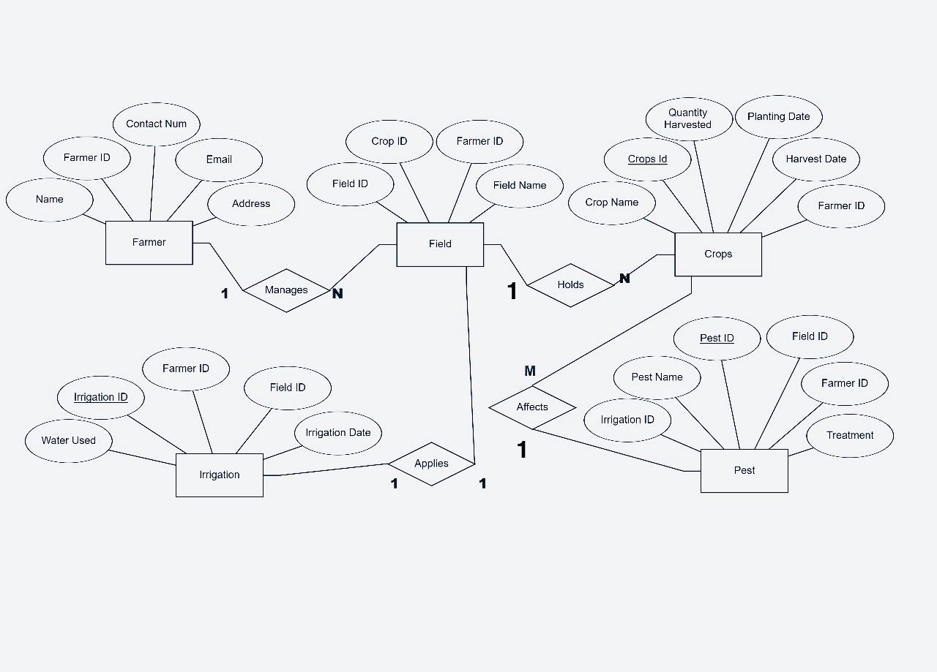**3.ER Diagram**

**4.Schema Diagram**

**Farmers**

|  |  |  |  |  |
| --- | --- | --- | --- | --- |
| **Farmer_ID** | **Name** | **Contact_num** | **Email** | **Address** |

**Crops**

|  |  |  |  |  |  |
| --- | --- | --- | --- | --- | --- |
| **CropID** | **CropName** | **PlantingDate** | **HarvestDate** | **QuantityHarvested** | **Farmer_ID** |

**Field**

|  |  |  |  |
| --- | --- | --- | --- |
| **FieldID** | **FieldName** | **CropID** | **Farmer_Id** |

**Irrigation**

|  |  |  |  |  |  |
| --- | --- | --- | --- | --- | --- |
| **IrrigationID** | **FeildID** | **IrrigationDate** | **WaterUsed** | **PestID** | **Farmer_id** |

**Pests**

|  |  |  |  |  |  |
| --- | --- | --- | --- | --- | --- |
| **PestID** | **FieldID** | **PestName** | **IrrigationID** | **Treatment** | **Farmer_ID** |

**5.Table Creation**

**i) Farmer table:**

create table Farmers (

Farmer_ID int,

Name varchar(20),

ContactNum varchar(10),

Email varchar(15),

Address varchar(20),

primary key(Farmer_ID)

);

**OUTPUT:**

**ii) Crop table:**

create table Crops (

CropID int,

CropName varchar(20),

QuantityHarvested int,

FarmerID int,

primary key(CropID,FarmerID),

foreign key (FarmerID) references Farmers(FarmerID)

);

**Output:**

**ii) Field table:**

Create table Fields (

FieldID int,

FieldName varchar(15),

CropID int,

FarmerID int,

primary key(FieldID,CropID,FarmerID),

foreign key (CropID) references Crops(CropID),

foreign key (FarmerID) references Farmers(FarmerID));

**Output:**

**iv) Irrigation table:**

Create table Irrigation (

IrrigationID int,

FieldID int,

IrrigationDate date,

WaterUsed int,

PestID int,

FarmerID int,

primary key(IrrigationID,FeildID,FarmerID,PestID)

);

**Output:**

**v) Pests table:**

Create table Pests (

PestID int,

FieldID int,

PestName varchar(20),

IrrigationID int,

Treatment varchar(25),

FarmerID int,

primary key(PestID,FieldID,FarmerID),

foreign key(FarmerID) references Farmers(FarmerID));

**Output:**

**6.Inserting values**

**i) Query for inserting into Farmers:**

Insert into farmer values(1,’xxx’,789,’xxx@gmail.com’,’Manglore’);

Insert into farmer values(2,’yyy’,890,’yyy@gmail.com’,’Bengalore’);

Insert into farmer values(3,’zzz’,678,’zzz@gmail.com’,’Udupi’);

**Output:**

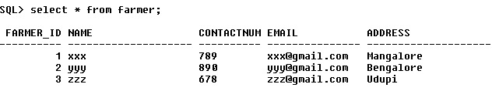

**ii) Query for inserting into Crops:**

Insert into crop value(1,’RTR’,25,1);

Insert into crop value(2,’STS’,30,2);

Insert into crop value(3,’UTU’,35,3);

**Output:**

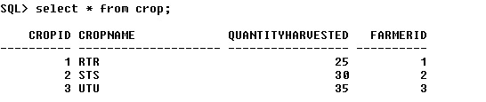

**iii) Query for inserting into Fields:**

Insert into fields values(1,’TTT’,123,1);

Insert into fields values(2,’WWW’,345,2);

Insert into fields values(3,’ZZZ’,456,3);

**Output:**

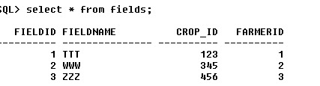

**iv) Query for inserting into Irrigation:**

Insert into irrigation values(1,222,100,10);

Insert into irrigation values(2,333,200,20);

Insert into irrigation values(3,444,300,30);

**Output:**

**v) Query for inserting into Pests:**

Insert into pests values(‘WEDT’,100,222,’ABC’10,1);

Insert into pests values(‘TEBT’,200,333,’DEF’20,2);

Insert into pests values(‘REBT’,300,444,’GHI’30,3);

**Output:**

**7.Sample Queries**

**i) Count the number of distinct pests recorded for each field.**

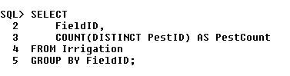

**Output:**

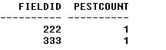

**ii) This query combines the names of farmers and the names of crops into a single result set.**

**Output:**

**iii) Query for common FieldIDs Fields and Irrigation tables.**

**Output:**

**iv) These queries demonstrate various ways to use the JOIN operator to link the Pests and Crops tables based on the FarmerID field.**

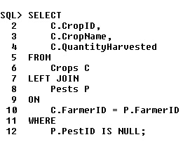

**Output:**

**v) Calculate the average amount of water used for irrigation per field**

**Output:**

**8.Conclusion:**

* **Cost Savings: By optimizing resource usage (water, fertilizers, pesticides), farmers can reduce input costs while maximizing output, improving overall profitability.**
* **Environmental Sustainability: Implementing precision farming techniques minimizes environmental impact by reducing chemical usage, conserving water, and promoting soil health.**
* **Data-Driven Insights: Continuous monitoring and data analysis provide valuable insights into long-term trends and patterns, aiding in long-range planning and risk management.**
* **Empowerment of Farmers: Empowering farmers with technology fosters a more resilient agricultural sector, attracting younger generations to farming and ensuring its sustainability.**
* **Market Competitiveness: Adopting advanced agricultural technologies enhances competitiveness by producing high-quality crops consistently and meeting regulatory standards effectively.**